CIP-B102 Foundations of Computer and Digital Forensics
Lab 7: Steganography and Hidden Data Detection
Digital Forensics Lab Report
Student Name | Fuseini Imoru Kantuogaa
Course Code | CIP-B102
Lab Title | Lab 7: Steganography and Hidden Data Detection
Date | July 15, 2026
Instructor’s Name | Dr. Sarah James
Operating System Used | Kali Linux (kali@kali)

1. Pre-Lab Confirmation
I confirm that the Steganography slide walkthrough was studied in full before beginning this practical lab, including the concepts of hiding information inside files, insertion and substitution methods, least significant bit (LSB) encoding in bitmap images, steghide usage, extraction, password dictionary preparation, and stegseek.

2. Tools Used
- steghide — used to embed and extract hidden files inside the BMP carrier image.
- stegseek 0.6 — used to perform a dictionary-based password recovery attack against the stego images.
- wget — used to download the carrier image from the provided Google Drive link.
- file — used to confirm file type/format of the carrier and stego images.
- sha256sum — used to generate and compare cryptographic hashes of all evidence files.
- xxd — used to inspect the raw hexadecimal header bytes of the images.
- strings — used to search for readable text fragments inside the stego image.
- diff — used to confirm byte-for-byte equality between original and extracted files.
All tools listed above were already available on the Kali Linux lab VM and were verified as working throughout the exercise (each command executed successfully and produced the expected output shown in the procedure below).

3. Download Evidence
Source URL used:
https://drive.google.com/file/d/1CE-4EOe9-HEF_9mg3Y4N7u15qUbIlDm0/view?usp=sharing (accessed via its direct-download form).
The working folder ~/CIP-B102-Lab7-Steganography was created first, then the carrier image was downloaded directly from the command line using wget with the direct-download URL format. The download completed successfully as an 8.8 MB file named tower_original_image_for_lab.bmp.
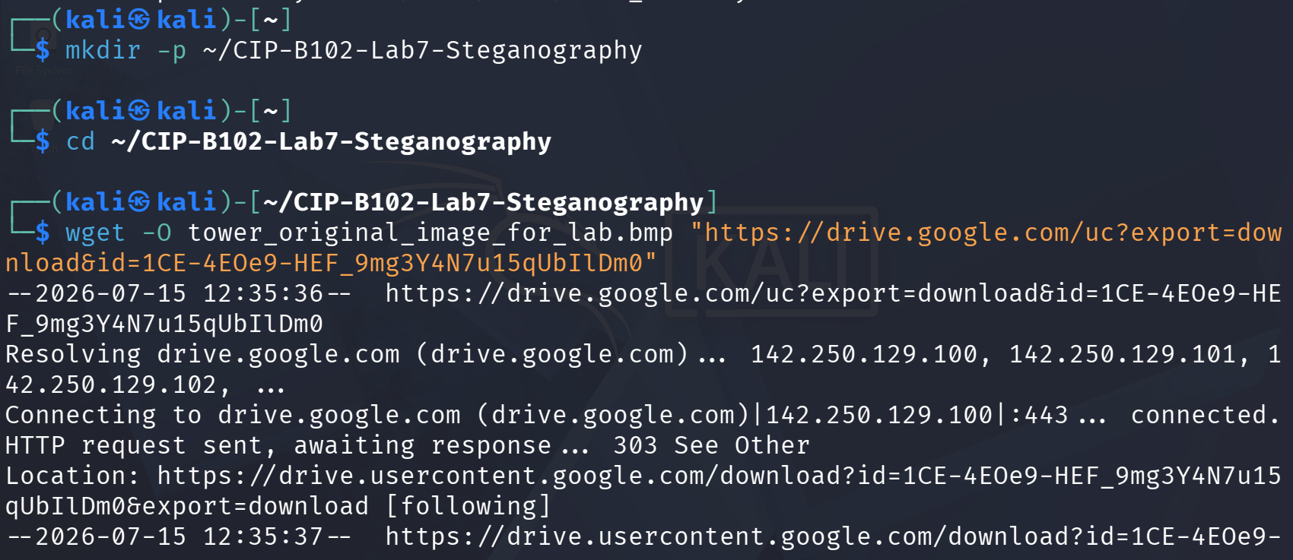
Figure 1 — Working folder created and wget download of the carrier image started.
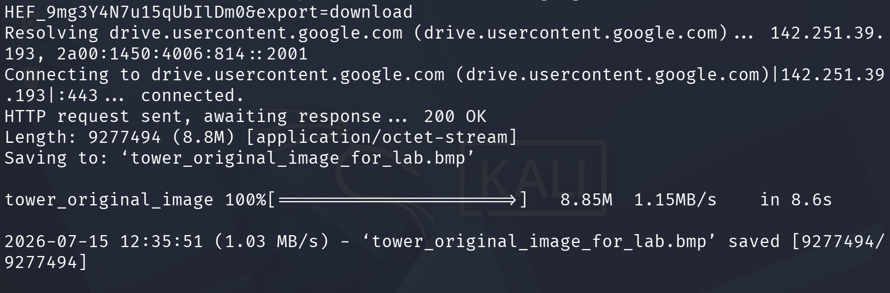
Figure 2 — wget download completes successfully (200 OK, 9,277,494 bytes saved).

4. Procedure

Part A — Prepare the Working Folder and Download the Carrier Image
After the download, the directory listing, file type, and SHA-256 hash of the original carrier image were recorded before any modification, to preserve a verifiable baseline.
ls -lh
file tower_original_image_for_lab.bmp
sha256sum tower_original_image_for_lab.bmp > lab7_hashes.txt
cat lab7_hashes.txt
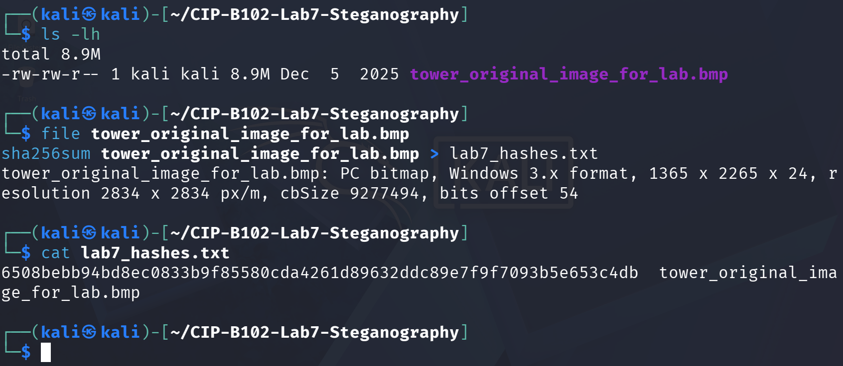
Figure 3 — Directory listing, file-type confirmation (Windows 3.x BMP, 1365x2265), and SHA-256 hash of the original image recorded in lab7_hashes.txt.
The file command confirmed the download was a genuine Windows 3.x bitmap (not an HTML error page), and the original hash 6508beb...e653c4db was captured as the baseline for later comparison.

Part B — Create the Secret Evidence Text File
A small evidence note containing my name was created with a heredoc so its exact content could be verified afterward, then its type and hash were recorded.
cat > secret.txt << 'EOF'
ICDFA CIP-B102 Lab 7 Evidence Note
Student Name: Fuseini Imoru
Message: This file was hidden and recovered during a controlled steganography lab.
EOF
cat secret.txt
file secret.txt
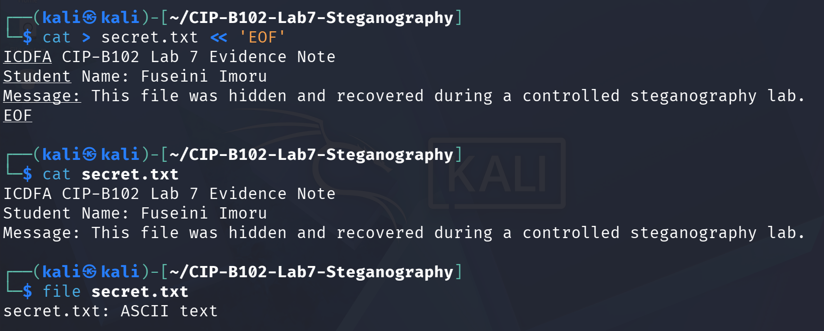
Figure 4 — secret.txt created and its content displayed; confirmed as ASCII text.
sha256sum secret.txt >> lab7_hashes.txt
cat lab7_hashes.txt
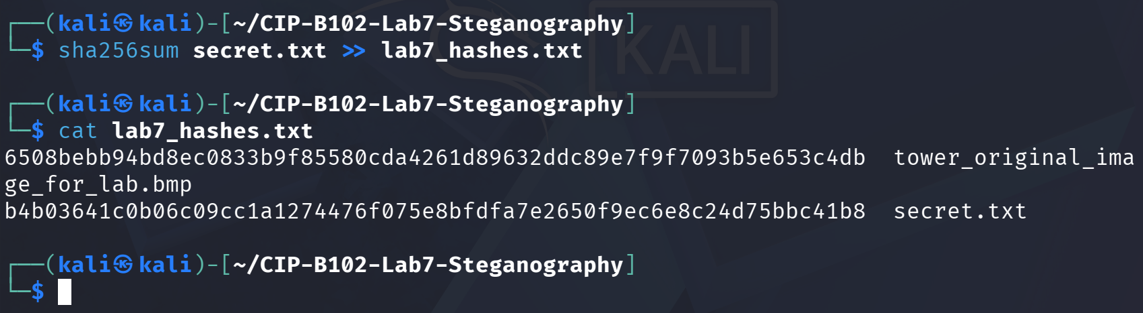
Figure 5 — Hash of secret.txt (b4b0364...bc41b8) appended to lab7_hashes.txt.

Part C — Hide the Secret File Using Steghide
steghide embed was used to hide secret.txt inside the carrier image using LSB/substitution encoding, protected with the lab password 1234. A new file, tower_stego_lab7.bmp, was written so the original carrier image was never overwritten.
steghide embed -ef secret.txt -cf tower_original_image_for_lab.bmp \
-sf tower_stego_lab7.bmp -p 1234
ls -lh tower_original_image_for_lab.bmp tower_stego_lab7.bmp
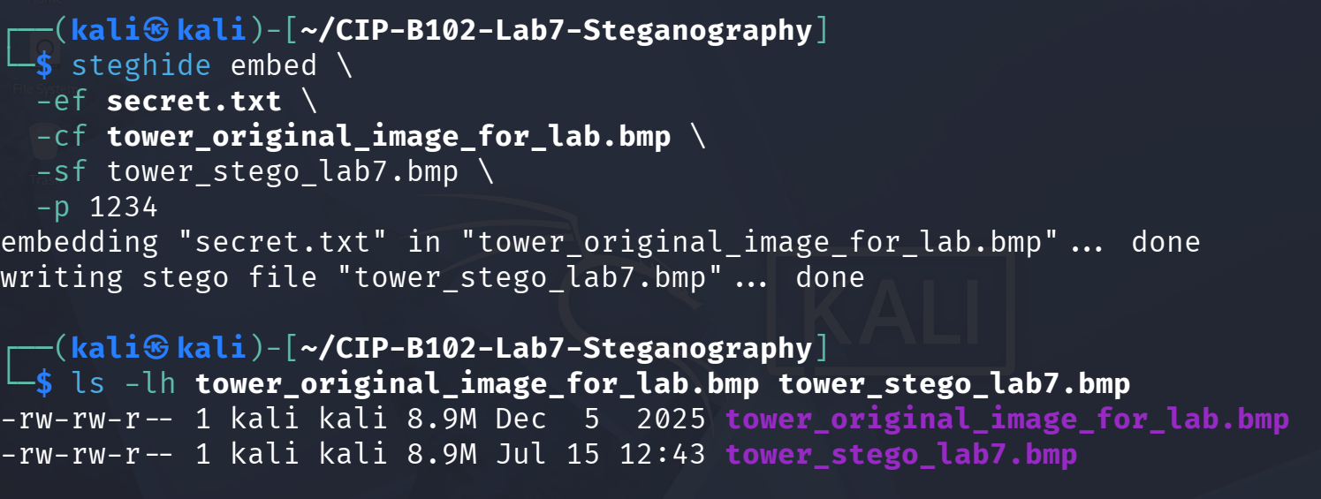
Figure 6 — steghide embed completes successfully; both the original and new stego image (same 8.9M visible size) are listed.
file tower_stego_lab7.bmp
sha256sum tower_stego_lab7.bmp >> lab7_hashes.txt
cat lab7_hashes.txt
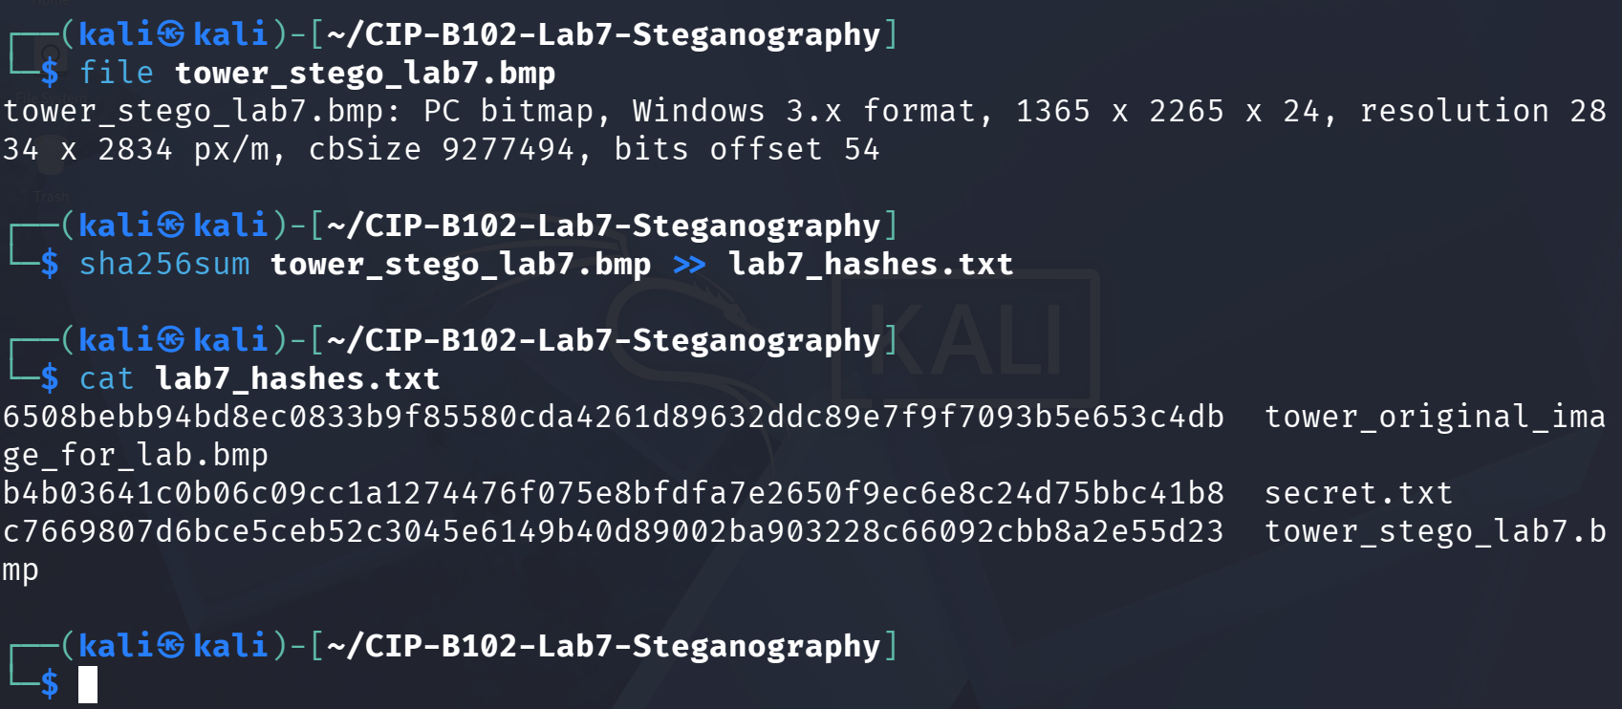
Figure 7 — Stego image confirmed as a valid BMP of identical dimensions; its hash (c766980...2e55d23) is different from the original image's hash.
Explanation: although the reported file size and image dimensions are unchanged, embedding secret.txt altered the least-significant bits of many pixel bytes. Because SHA-256 is sensitive to any single-bit change, the stego image hash differs completely from the original image hash even though the two files look visually identical.

Part D — Extract the Hidden File Using the Correct Password
The hidden file was extracted from the stego image with the correct password, and the recovered content was displayed and compared against the original secret file.
mkdir -p extracted
steghide extract -sf tower_stego_lab7.bmp \
-xf extracted/extracted_secret.txt -p 1234
cat extracted/extracted_secret.txt
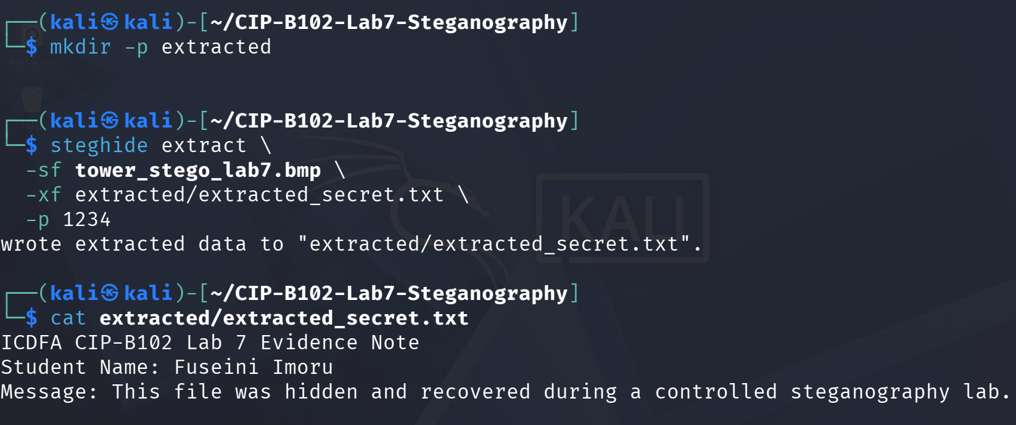
Figure 8 — steghide extract recovers the hidden data; the recovered text matches the original evidence note exactly.
sha256sum extracted/extracted_secret.txt >> lab7_hashes.txt
diff secret.txt extracted/extracted_secret.txt && echo "MATCH: extracted file is identical"
sha256sum secret.txt extracted/extracted_secret.txt
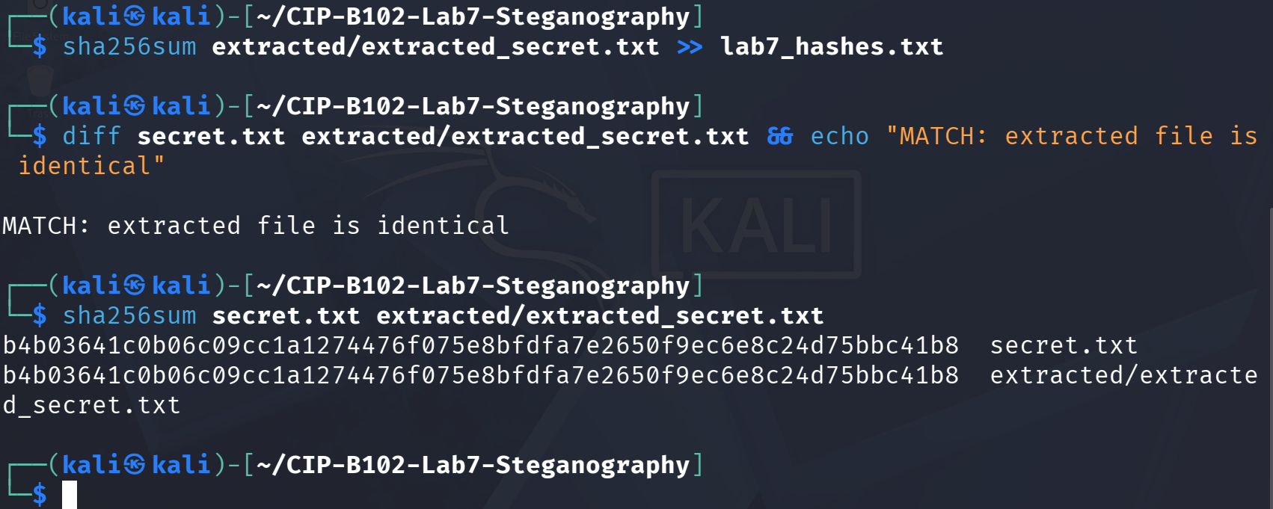
Figure 9 — diff reports MATCH, and sha256sum confirms secret.txt and the extracted file share the identical hash b4b0364...bc41b8.
This proves the recovered file is a perfect, forensically sound copy of the original hidden evidence no data was lost or altered during embedding or extraction.

Part E — Basic Visual and Binary Comparison
The original and stego images were compared at the file-system, hash, and raw-byte level to demonstrate that a visually identical image can carry different underlying data.
ls -lh tower_original_image_for_lab.bmp tower_stego_lab7.bmp
sha256sum tower_original_image_for_lab.bmp tower_stego_lab7.bmp
xxd -l 64 tower_original_image_for_lab.bmp
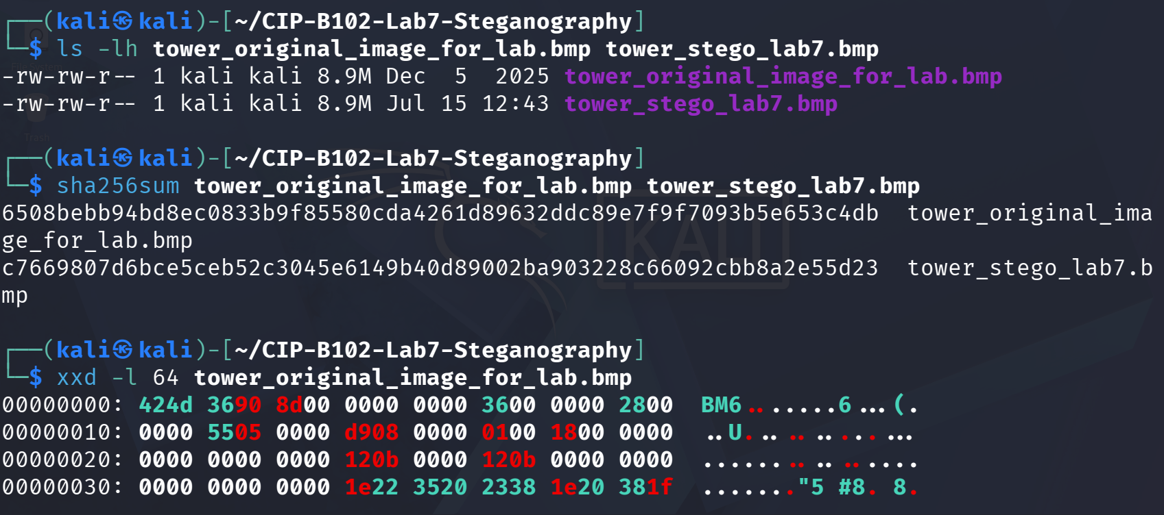
Figure 10 — File sizes are identical, but the SHA-256 hashes differ; first 64 bytes of the original image's BMP header shown with xxd.
xxd -l 64 tower_stego_lab7.bmp
strings tower_stego_lab7.bmp | head -n 20
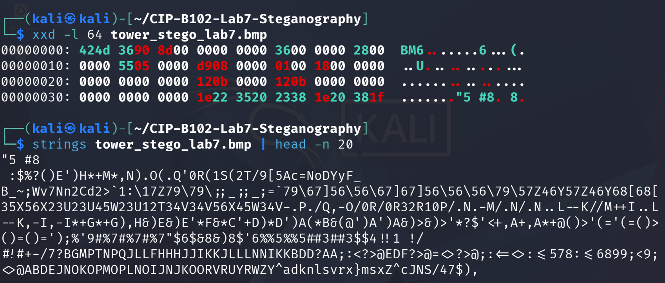
Figure 11 — First 64 bytes of the stego image's BMP header (identical structure to the original), followed by the start of the strings output on the pixel data.
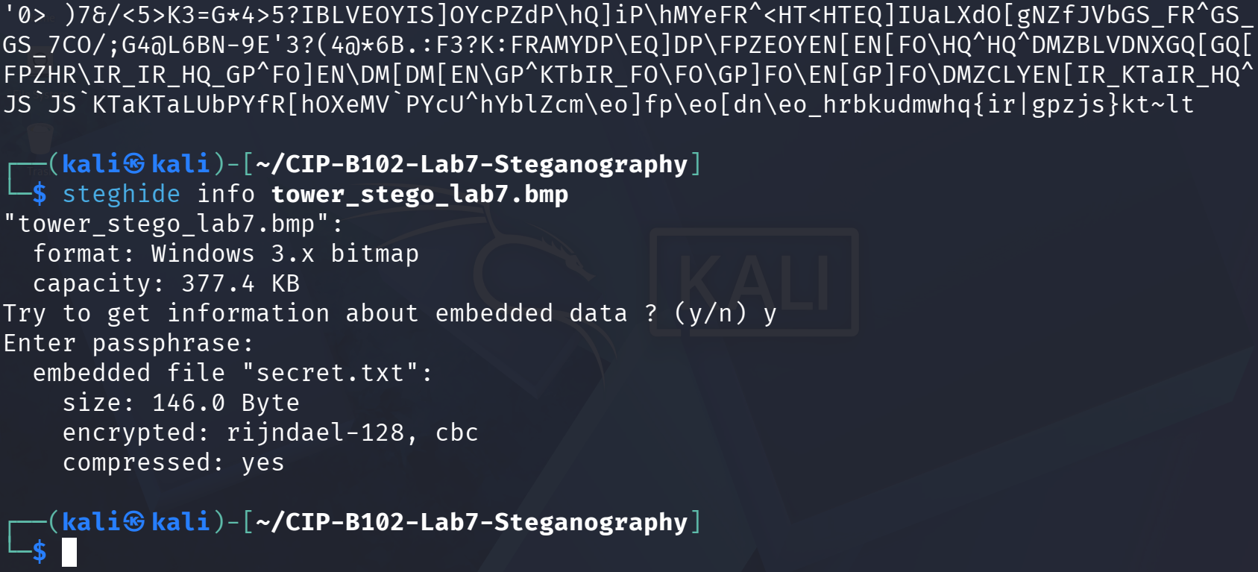
Figure 12 — Continued strings output showing unreadable, high-entropy pixel data, followed by steghide info confirming a 146-byte AES(rijndael-128)-encrypted, compressed payload named secret.txt embedded in the file.
Interpretation: the BMP headers (first 64 bytes) of the two files are byte-for-byte identical, and the strings output shows no readable evidence of the hidden file — the pixel data simply reads as noise either way. This confirms that neither the header nor a visual/textual inspection is sufficient to detect steganography; only a hash comparison or a tool such as steghide/stegseek can reveal that hidden data is present.

Part F — Password Dictionary Test with Stegseek
A small custom wordlist containing the known lab password (1234) alongside several common weak passwords was created, then stegseek was run against the stego image to test whether the password could be recovered automatically.
cat > lab7_wordlist.txt << 'EOF'
password
admin
icdfa
cybersecurity
1234
letmein
EOF
cat lab7_wordlist.txt
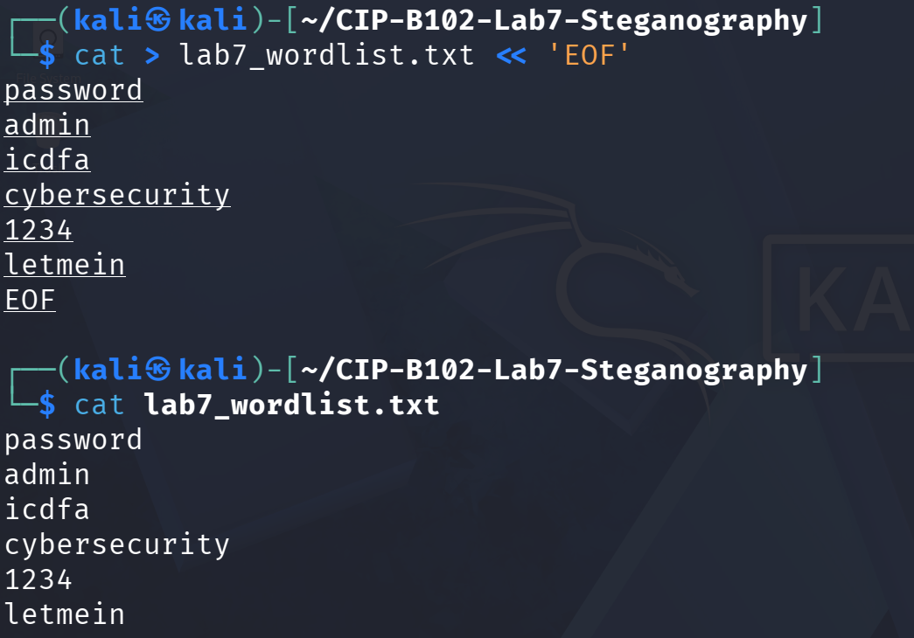
Figure 13 — Custom lab7_wordlist.txt created and displayed, containing six candidate passwords including 1234.
stegseek tower_stego_lab7.bmp lab7_wordlist.txt
ls -lh
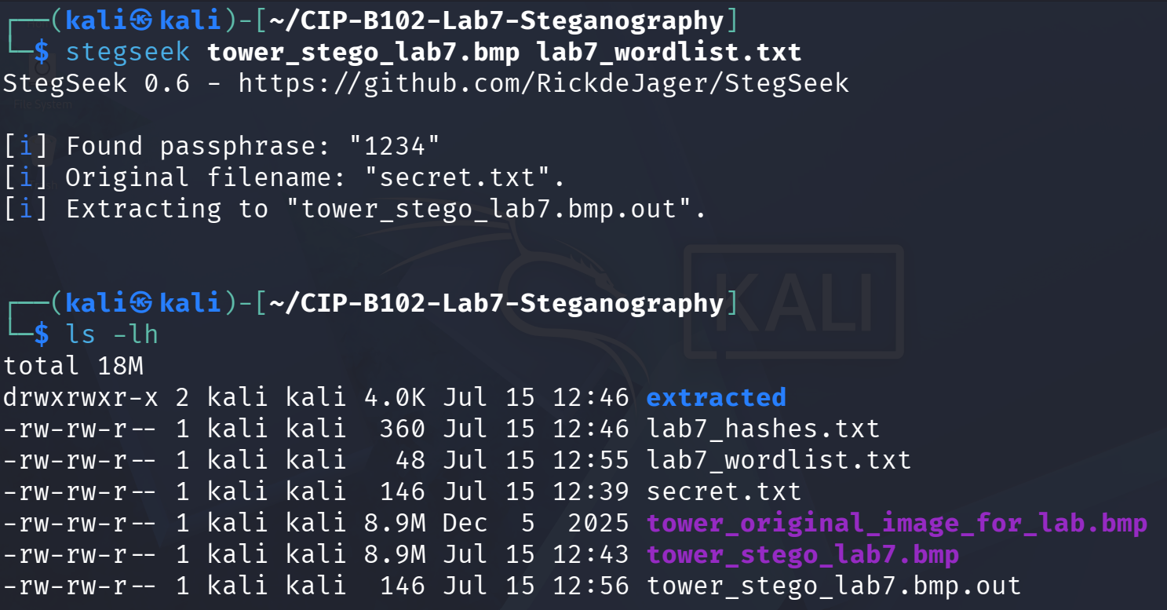
Figure 14 — stegseek 0.6 finds the passphrase "1234" almost instantly, identifies the original filename secret.txt, and extracts it to tower_stego_lab7.bmp.out.
Explanation: because the embedding password (1234) was included in the six-word test dictionary, stegseek recovered it in a fraction of a second and automatically extracted the hidden file without steghide's password even being supplied manually. This demonstrates why weak or common passwords are dangerous in steganography any password that appears in a small, easily-guessed wordlist (let alone a large real-world list such as rockyou.txt) can be defeated almost instantly by automated dictionary attacks. A strong, unique passphrase is essential for the hidden data to resist this kind of attack.

Part G — Independent Student Task
A separate steganography evidence file was created, embedded, extracted, and password-tested independently, following the same workflow as Parts B–F but with my own content and stego image.
cat > fuseini_imoru_hidden_note.txt << 'EOF'
Steganography is the practice of hiding information inside another file, such as an
image, audio file, or video file.
In digital forensics, steganography matters because investigators may encounter files
that appear normal but secretly contain hidden evidence, confidential information,
or malicious content. Understanding how to detect and recover hidden data is an
important forensic skill.
EOF
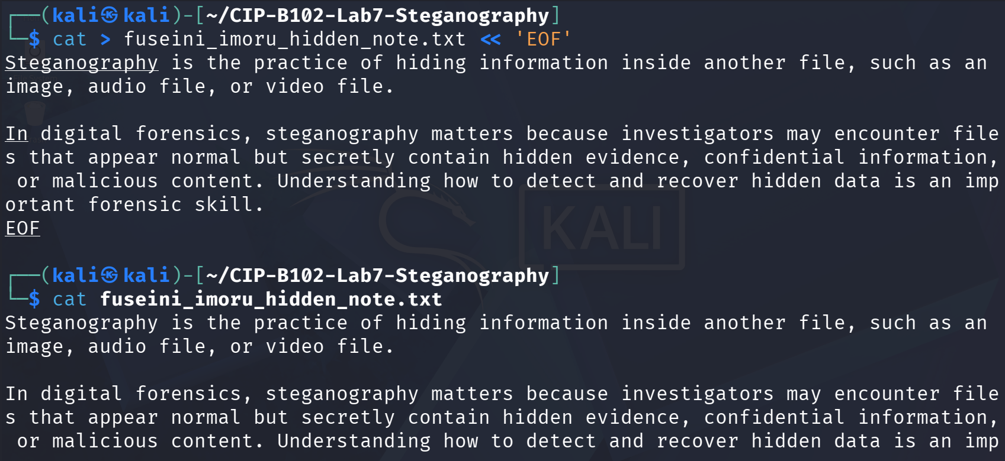
Figure 15 — Independent evidence note fuseini_imoru_hidden_note.txt created, explaining what steganography is and why it matters in forensics.
steghide embed -ef fuseini_imoru_hidden_note.txt \
-cf tower_original_image_for_lab.bmp -sf tower_stego_partG.bmp -p 1234
sha256sum fuseini_imoru_hidden_note.txt
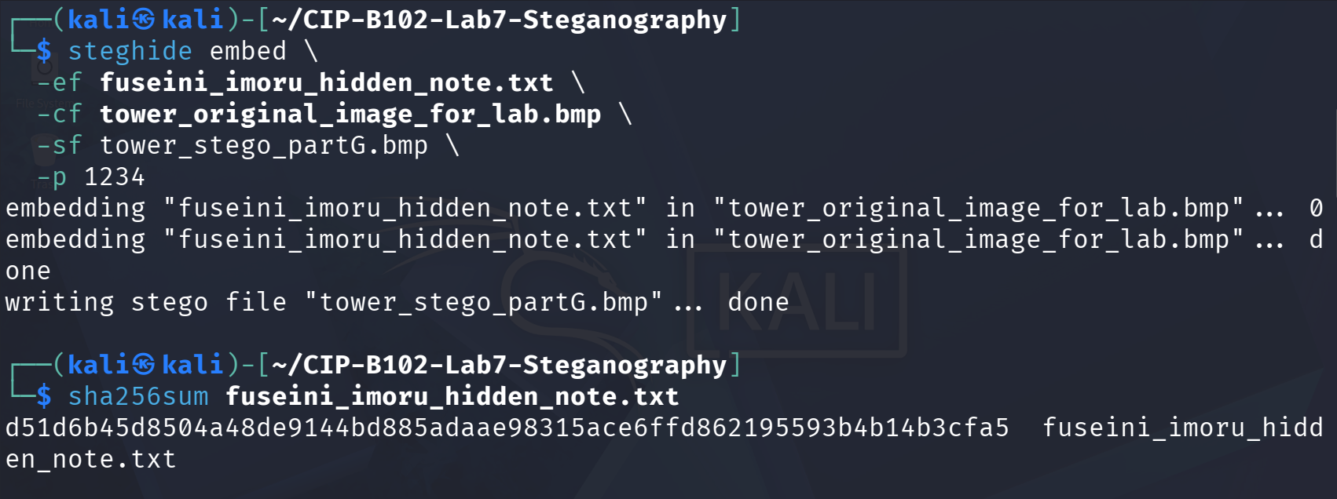
Figure 16 — Independent note embedded into a new stego image tower_stego_partG.bmp; hash of the original note recorded (d51d6b4...b3cfa5).
sha256sum tower_stego_partG.bmp
mkdir -p partG_extract
steghide extract -sf tower_stego_partG.bmp \
-xf partG_extract/recovered_note.txt -p 1234
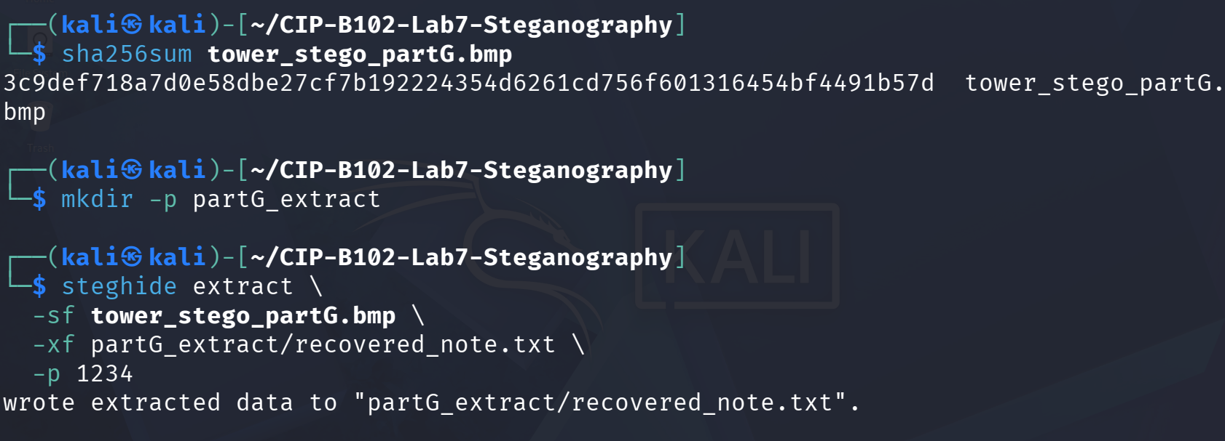
Figure 17 — Hash of the stego image recorded, then the hidden note successfully extracted to partG_extract/recovered_note.txt.
sha256sum fuseini_imoru_hidden_note.txt partG_extract/recovered_note.txt
diff fuseini_imoru_hidden_note.txt partG_extract/recovered_note.txt && echo "MATCH: files are identical"
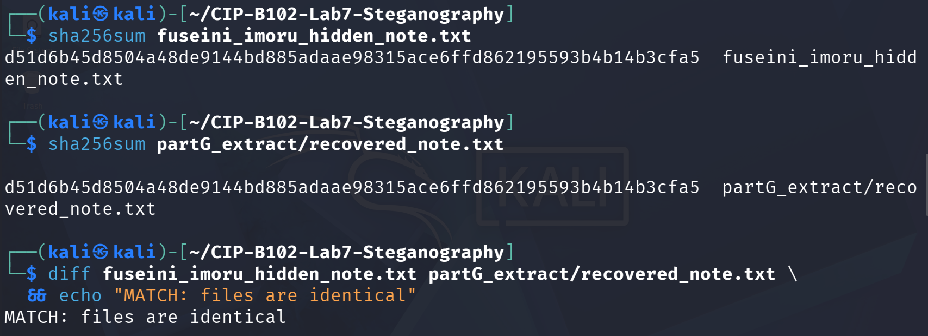
Figure 18 — The original and recovered note share the identical hash d51d6b4...b3cfa5, and diff confirms MATCH.
cat > partG_wordlist.txt << 'EOF'
password
admin
forensics
cybersecurity
1234
letmein
EOF
stegseek tower_stego_partG.bmp partG_wordlist.txt
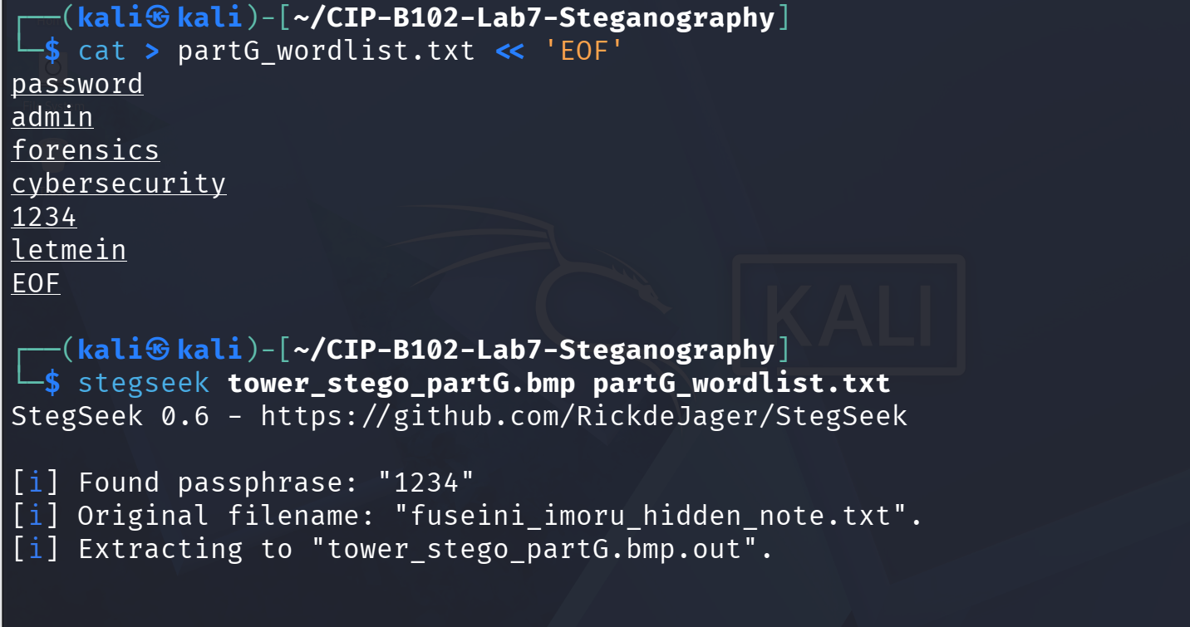
Figure 19 — A second mini dictionary was tested against tower_stego_partG.bmp; stegseek again recovers the passphrase "1234" and correctly identifies the original filename.
Note on password handling: the embedding password used for the independent task is recorded here and in my private notes as 1234 (chosen so the recovery step could be verified); per the lab instructions this is not presented as a "secret" on the report cover page.

5. Hash Table Summary
The following SHA-256 hashes were recorded in lab7_hashes.txt and verified throughout the exercise:
File | Stage | SHA-256 Hash
tower_original_image_for_lab.bmp | Original carrier image | 6508bebb94bd8ec0833b9f85580cda4  261d89632ddc89e7f9f7093b5e653c4db
secret.txt | Original secret file (Part B) | b4b03641c0b06c09cc1a1274476f075  e8bfdfa7e2650f9ec6e8c24d75bbc41b8
tower_stego_lab7.bmp | Stego image after embedding (Part C) | c7669807d6bce5ceb52c3045e6149b40d8  9002ba903228c66092cbb8a2e55d23
extracted/extracted_secret.txt | Extracted file (Part D) | b4b03641c0b06c09cc1a1274476f07  5e8bfdfa7e2650f9ec6e8c24d75bbc41b8
fuseini_imoru_hidden_note.txt | Independent task original note (Part G) | d51d6b45d8504a48de9144bd885adaae  98315ace6ffd862195593b4b14b3cfa5
tower_stego_partG.bmp | Independent task stego image (Part G) | 3c9def718a7d0e58dbe27cf7b192224354d  6261cd756f601316454bf4491b57d
partG_extract/recovered_note.txt | Independent task recovered file (Part G) | d51d6b45d8504a48de9144bd885adaae98315  ace6ffd862195593b4b14b3cfa5

6. Findings
- The hidden file was recovered successfully in every case: the guided Part D extraction and the independent Part G extraction both produced files that are byte-for-byte identical to their originals (confirmed by diff and matching SHA-256 hashes).
- Embedding data with steghide changed the SHA-256 hash of the carrier image (Part C/E) without changing its visible dimensions, apparent file size on disk, or the readable structure of its BMP header confirming that hash comparison, not visual inspection, is the reliable way to detect that a file has been modified.
- Both the guided stego image (password 1234) and the independently created stego image (also password 1234) were defeated instantly by stegseek once that password was present in a small custom wordlist.

7. Password Test Results
stegseek 0.6 was run against both stego images produced in this lab. In both cases it recovered the passphrase "1234" from a six-entry custom wordlist in well under a second, correctly identified the original embedded filename, and automatically extracted the hidden payload. No installation or execution failures were encountered, so no fallback/troubleshooting steps were required.

8. Reflection
This lab demonstrated that steganography hides the existence of data rather than encrypting its content unlike encryption, which scrambles data so it is unreadable but still visibly present, steganography conceals data inside another file (here, the least-significant bits of a bitmap image) so that no obvious evidence of hidden information exists at all. The exercise showed that a stego image can be dimensionally and visually identical to its source while carrying a completely different hash, which is why forensic examiners rely on cryptographic hashing, header/structure analysis, and dedicated tools such as steghide and stegseek rather than the naked eye when screening evidence for hidden data. The stegseek results in Parts F and G were a clear illustration of why password strength matters: a four-digit numeric password was recovered from a six-word dictionary almost instantly, and would be recovered just as easily from a large real-world wordlist such as rockyou.txt. In an actual investigation, being able to test suspect files against common wordlists and knowing that weak passphrases offer negligible real protection is directly relevant to uncovering concealed evidence, malicious payloads, or exfiltrated data hidden inside seemingly ordinary image files.

9. Reflection Questions
1. What is steganography and how is it different from encryption?
Steganography hides the existence of data by concealing it inside another file so it is not apparent that any hidden data exists. Encryption instead scrambles data so it cannot be read without a key, but the presence of encrypted data is usually still visible.
2. Why are BMP images commonly used when explaining LSB steganography?
BMP files store pixel data uncompressed, so each pixel's least-significant bits can be modified predictably without a compression algorithm re-encoding or discarding the changes, making the LSB substitution technique easy to demonstrate and reverse.
3. Why does the stego image hash change after embedding a file?
Embedding alters the least-significant bits of numerous pixel bytes throughout the image. SHA-256 produces a completely different digest for any change, even a single bit, so the stego image's hash no longer matches the original.
4. Can a normal visual inspection prove whether an image contains hidden data? Explain.
No. As shown in Part E, the original and stego images were visually and dimensionally identical, and their BMP headers matched byte-for-byte; only a hash comparison or a steganalysis tool revealed the difference.
5. Why is password strength important when using steghide?
As demonstrated in Parts F and G, a weak four-digit password was recovered by stegseek in under a second using a tiny custom wordlist. A weak password gives essentially no real protection against automated dictionary attacks.
6. How can steganography be relevant in digital forensic investigations?
Suspects may use steganography to conceal evidence, stolen data, or communications inside ordinary-looking image, audio, or video files. Investigators must know how to detect (via hashing/steganalysis) and, where a weak password is used, recover such hidden data during an examination.

10. Appendix — Full Command Log
mkdir -p ~/CIP-B102-Lab7-Steganography
cd ~/CIP-B102-Lab7-Steganography
wget -O tower_original_image_for_lab.bmp "https://drive.google.com/uc?export=download&id=1CE-4EOe9-HEF_9mg3Y4N7u15qUbIlDm0"
ls -lh
file tower_original_image_for_lab.bmp
sha256sum tower_original_image_for_lab.bmp > lab7_hashes.txt
cat lab7_hashes.txt
cat > secret.txt << 'EOF'
ICDFA CIP-B102 Lab 7 Evidence Note
Student Name: Fuseini Imoru
Message: This file was hidden and recovered during a controlled steganography lab.
EOF
cat secret.txt
file secret.txt
sha256sum secret.txt >> lab7_hashes.txt
steghide embed -ef secret.txt -cf tower_original_image_for_lab.bmp -sf tower_stego_lab7.bmp -p 1234
ls -lh tower_original_image_for_lab.bmp tower_stego_lab7.bmp
file tower_stego_lab7.bmp
sha256sum tower_stego_lab7.bmp >> lab7_hashes.txt
mkdir -p extracted
steghide extract -sf tower_stego_lab7.bmp -xf extracted/extracted_secret.txt -p 1234
cat extracted/extracted_secret.txt
sha256sum extracted/extracted_secret.txt >> lab7_hashes.txt
diff secret.txt extracted/extracted_secret.txt && echo "MATCH: extracted file is identical"
sha256sum secret.txt extracted/extracted_secret.txt
sha256sum tower_original_image_for_lab.bmp tower_stego_lab7.bmp
xxd -l 64 tower_original_image_for_lab.bmp
xxd -l 64 tower_stego_lab7.bmp
strings tower_stego_lab7.bmp | head -n 20
steghide info tower_stego_lab7.bmp
cat > lab7_wordlist.txt << 'EOF'
password / admin / icdfa / cybersecurity / 1234 / letmein
EOF
stegseek tower_stego_lab7.bmp lab7_wordlist.txt
cat > fuseini_imoru_hidden_note.txt << 'EOF'
(independent evidence note text)
EOF
steghide embed -ef fuseini_imoru_hidden_note.txt -cf tower_original_image_for_lab.bmp -sf tower_stego_partG.bmp -p 1234
sha256sum fuseini_imoru_hidden_note.txt
sha256sum tower_stego_partG.bmp
mkdir -p partG_extract
steghide extract -sf tower_stego_partG.bmp -xf partG_extract/recovered_note.txt -p 1234
sha256sum fuseini_imoru_hidden_note.txt partG_extract/recovered_note.txt
diff fuseini_imoru_hidden_note.txt partG_extract/recovered_note.txt && echo "MATCH: files are identical"
cat > partG_wordlist.txt << 'EOF'
password / admin / forensics / cybersecurity / 1234 / letmein
EOF
stegseek tower_stego_partG.bmp partG_wordlist.txt
No error messages were encountered during this lab; every command listed above completed successfully as shown in the corresponding figures.

